Dual Extruder Version 0.9 release testing report

The dual extruder V0.9 is the 2nd release candidate for the Dual Extruder printhead for the TAZ printer. It incorporates single-screw z-leveling as well as gussets connecting the 2 hot ends in an effort to prevent the calibration drift seen in the V0.75 Dual extruder (RC1).

Two nearly identical versions of the V0.9 Dual extruder were produced and tested, both with promising results. The first V0.9 prototype was assembled on january 23rd and tested in the cluster from Jan 24th to the 28th, racking up ~35 hours of printing with only negligible changes in the offset between the extruders (.14mm drift between the 2 farthest samples).

The second V0.9 Dual extruder that was tested had only cosmetic changes from the initial design (arrows added to indicate dial direction & heatset insert hole size increased for easier assembly). The second dual extruder assembly showed no measurable drift during the first 2 days of testing. The printer was moved from the cluster room to R&D for the open house; where the nozzle offset changed by .33mm in the Y direction. Because of the stability of the dual extruder prior to being moved, I believe that this change was caused mostly if not entirely by moving the printer.

Based on this, I believe that the V0.9 dual extruder is ready to be released, but that we need to recommend that the calibration procedure be run any time that the printer is moved.

Times that the Dual Extruder will need to be calibrated:
- every time that the dual extruder is mounted on the printer
- any time that the printer is transported
- after 40 hours of printing (~20 heat cycles)
- any time that color mismatch is obvious to the user

The calibration procedure is iterative, so careful measurement will allow users to calibrate the extruder in fewer tries. For initial setup, 3 iterations is usually enough to get the dual extruder calibrated well, with each iteration taking 5-10 minutes. Once the initial calibration is saved in slic3r, fewer iterations should be needed since the user will have a better starting point.

Times required for setup:
- Wiring for pre-guava machines 30 min to 1.5 hours depending on TAZ generation and user's comfort level with hardware and electronics
- Initial calibration (assuming 4 iterations) – 30min
- Additional calibrations (assuming 2 iterations) – 15 min

Here's a quick overview of the calibration procedure:
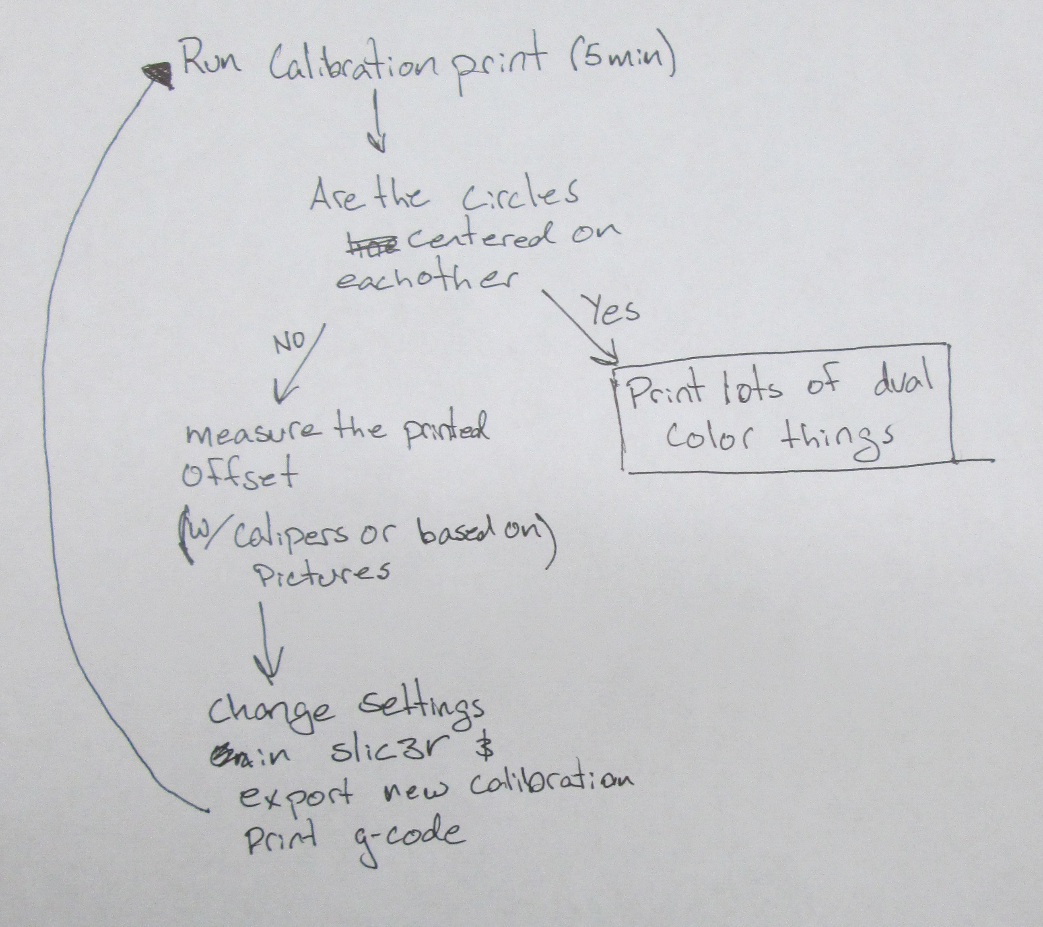

Documentation needed prior to Dual Extruder release:
- Setup guide
  - how to mount to printer
  - how to wire for 1.0, 2.0 and 3.0 Taz printers
  - firmware loading guide w/ extruder calibration for each extruder

- Calibration Guide
  - how to print the calibration bulls-eye
  - pictures of varying misalignment (+/- .5,1,1.5 mm in x and y)
  - guide covering slic3r w/ Dual extruder
    - how to generate amf.xml file from 2 .stl files
- Guide to printing with a dual extruder
  - tips on infil, layer heights and speed settings
  - good slic3r configs for dual extruder prints (fast, med, slow)

- Guide covering generation of 2 color stl files <---- ?

