Title: FCC & CE Testing
Test Plan: TP-RD-00008
Document Date: 11.23.15
Test Date: 11.20.15
Testing Location: EMI Test Lab LLC

PURPOSE:

Achieve FCC and CE compliance for AC mains conducted emissions, enclosure radiated emissions, and electrostatic discharge.

RESULTS SUMMARY:

During the examination, the Mangrove 03 passed FCC Class B by a margin of 3.0dBμV/m with 96MHz being the closest to the limit; the second closest was 128MHz which had a 4.8dBμV/m margin. The changes made to the machine include adding several ferrites (12 during the test), including a TVS ESD protection diode between GND and the digital pin (D22) used for auto-bed leveling where the bed washers are connected to the input pin, masking the powder coating of the inside of the cover to the chassis and the inside of the cover to the interconnect area, adding an AC-filtered receptacle, and electrically shorting the two X-rods and the right-Z-rod together.

During the test on 11/20/2015 we first focused on ensuring the machine passes Class A by completing the ESD and conducted emissions tests. Without the AC filter the machine barely passed the Class A requirement, once the filter was added the attenuation was enormous (~40dB). The conducted emissions test is part of the FCC Class A & B requirements; therefore, in order to pass the Class B requirement an AC filter was necessary. From the 10/30/2015 ESD test we learned that since the frame of the LCD display and the rotary encoder shaft are floating with respect to ground, discharges at the display and knob causes failures (freezes and resets). Adding insulation (plastic bezel, polycarbonate LCD cover, and plastic knob) prevented ESD issues. During the radiated emissions test we placed solid-core ferrites on each connector harness as well as the AC line (6 in total) in order to attenuate the common mode noise. After run through the spectrum there were three high magnitude outlier that was above the Class B limit. The frequencies included 96MHz and 160MHz (256MHz was -0.6dBμV/m). When examining the frequency in question (160MHz) we experimentally found that by moving both X-rods away from the chassis, adjusting the position of the right-Z-motor wiring, shortening the length of the D22 red wires leading to the bed, tightening the stainless steel screws mounting the RAMBo, and inverting the Y_MAX switch (now NC) we were able to attenuated each of the signals. The 96MHz was sourced by the 6th harmonic and 160MHz was sourced by the 10th harmonic of the clock signal of the ATmega2560 (this is a PCB layout issue of the RAMBo). In addition to each of these, prior to the examination we removed the powder coating of the inside of the cover to the chassis and the inside of the cover to the interconnect area as well as adding a TVS diode between the digital pin used for auto-bed leveling (D22) and GND.

The test 11/20/2015 included solid core ferrites we purchased as a potential for item for the final BoM. The ferrites we used resulted in attenuation better than the previous testing. The laptop (Thinkpenguin) we brought to testing introduced a high magnitude frequency of 480MHz. In addition, we shortened the length of the line and neutral wires of the AC line going to the power supply and replaced it with a 5mm inner diameter solid core ferrite. When printing from the SD card the margin below the Class B limit was 3.0dB. The highest magnitude was 96MHz.
CONCLUSION:

The results of the examination on 11/20/2015 showed that the TAZ 6 is capable of passing Class B.

In order to pass Class B, we need to incorporate the following changes to the Nutmeg machines:
EMC (Radiated Emissions) | ESD (Electrostatic Discharge) | Conducted Emissions
Add Solid Core Ferrites | Cover The LCD Display | AC Receptacle Filter
Ferrite Positions | Use A Plastic Knob
Mask Powder Coated Sheet Metal | Use The TVS Diode (D22 Bed)
Move Right-Z-Motor Wire Position
Tighten SS Screws on RAMBo
Invert Y_MAX Switch (NC)
Move X-Rods Away From Chassis

If the 96/160MHz frequencies is still an issue after the changes made to the Nutmeg phase then we will try changing the positions of the wires (Z_MIN switch and wires over the RAMBo) and if absolutely critical, adding additional ferrites.

BACKGROUND INFORMATION:

Common-mode noise is the predominant cause of radiation produced by equipment such as the Mangrove. Common-mode noise is when the same (in-phase) signal is present on both the positive and negative terminals of a load. Differential-mode (or normal-mode) is the case when the noise on the positive and negative lines are are out-of-phase causing a difference in potential across the load. The suppression necessary for common-mode noise is the use of a low-pass filter or choke (series inductance) on every line that is susceptible.
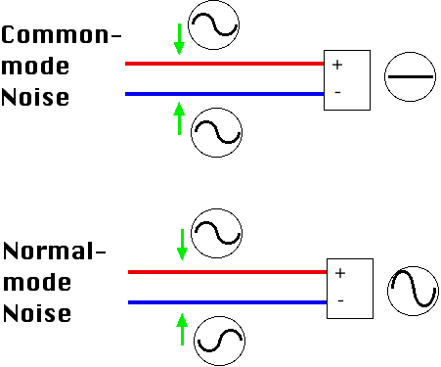
By No machine-readable author provided. NekoJaNekoJa~commonswiki assumed (based on copyright claims). [GFDL (http://www.gnu.org/copyleft/fdl.html), CC-BY-SA-3.0 (http://creativecommons.org/licenses/by-sa/3.0/) or CC BY-SA 2.5-2.0-1.0 (http://creativecommons.org/licenses/by-sa/2.5-2.0-1.0)], via Wikimedia Commons
EQUIPMENT:

An HP 8566B Spectrum Analyzer was used when testing radiated emissions.

Here are images of the machine in the EMI chamber:
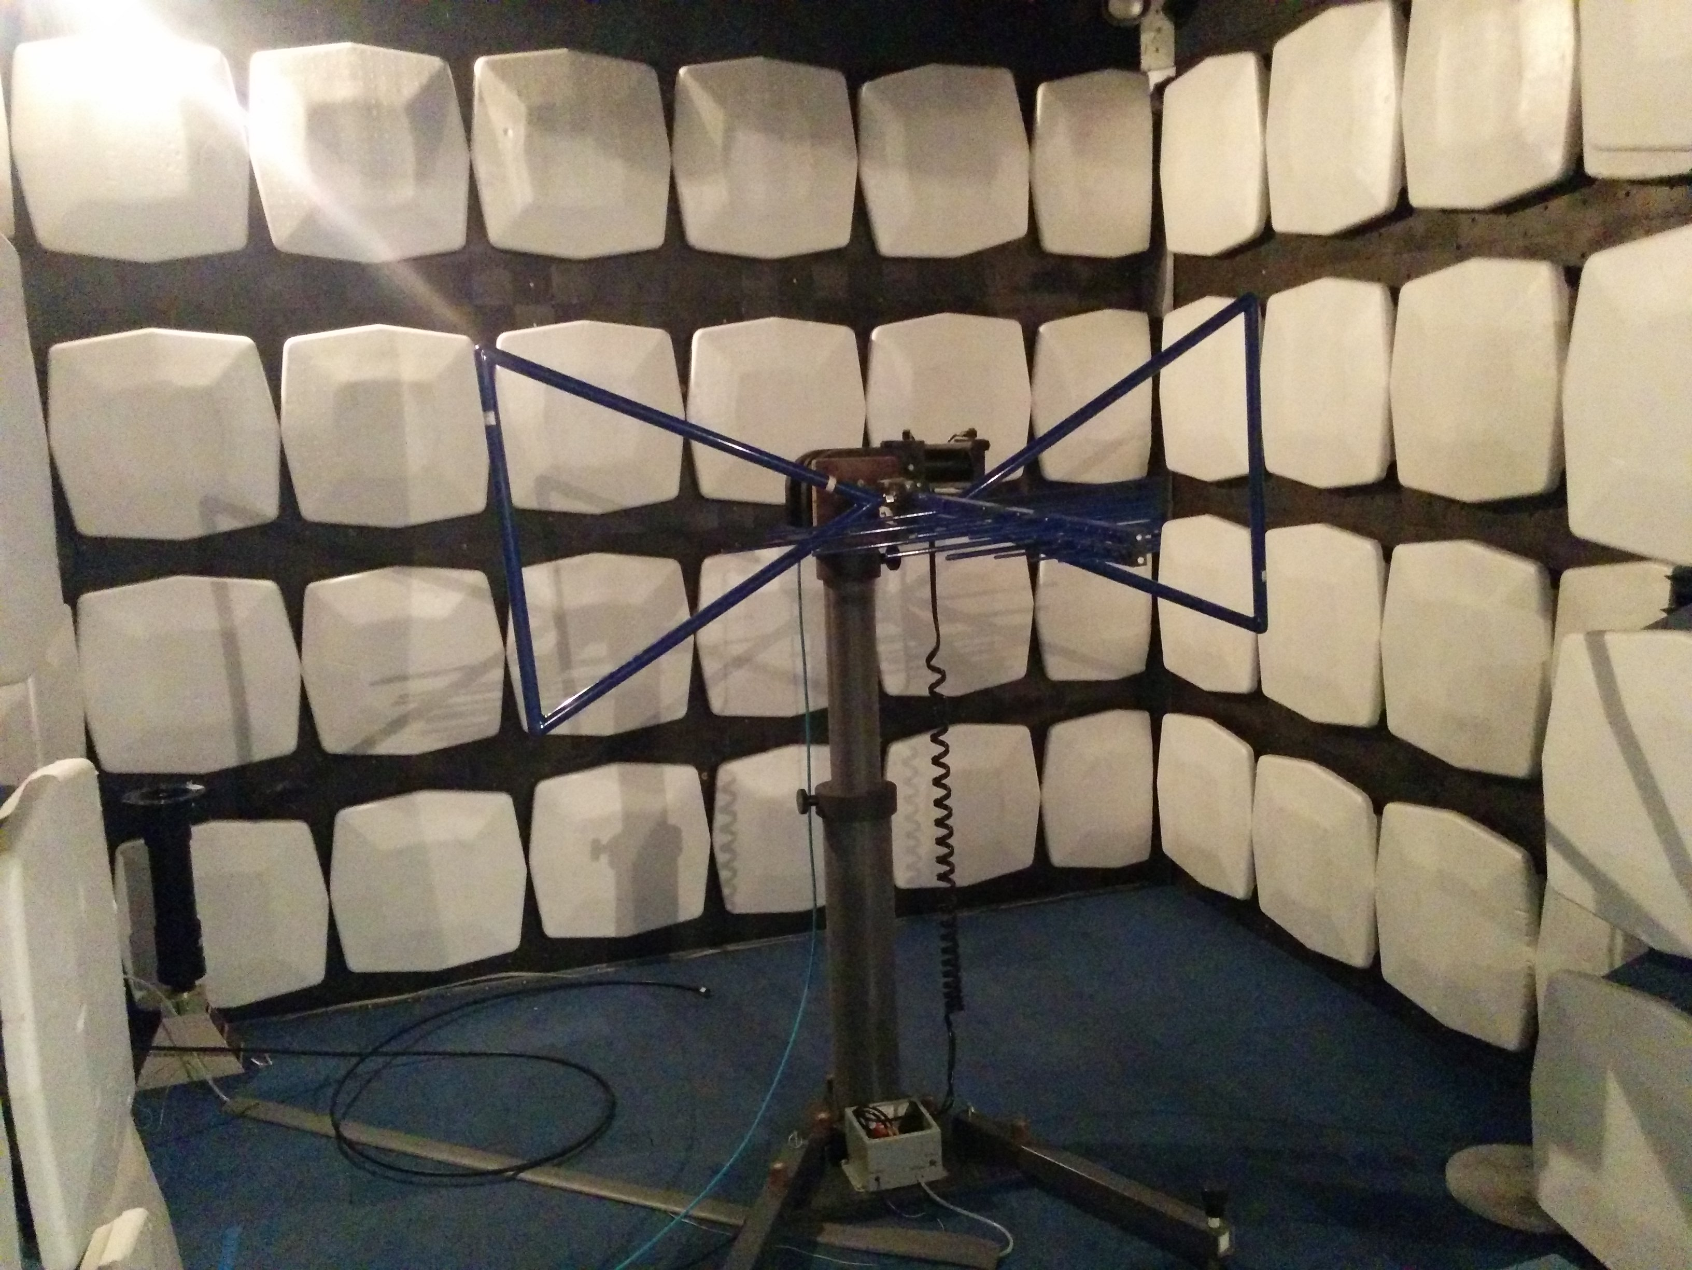
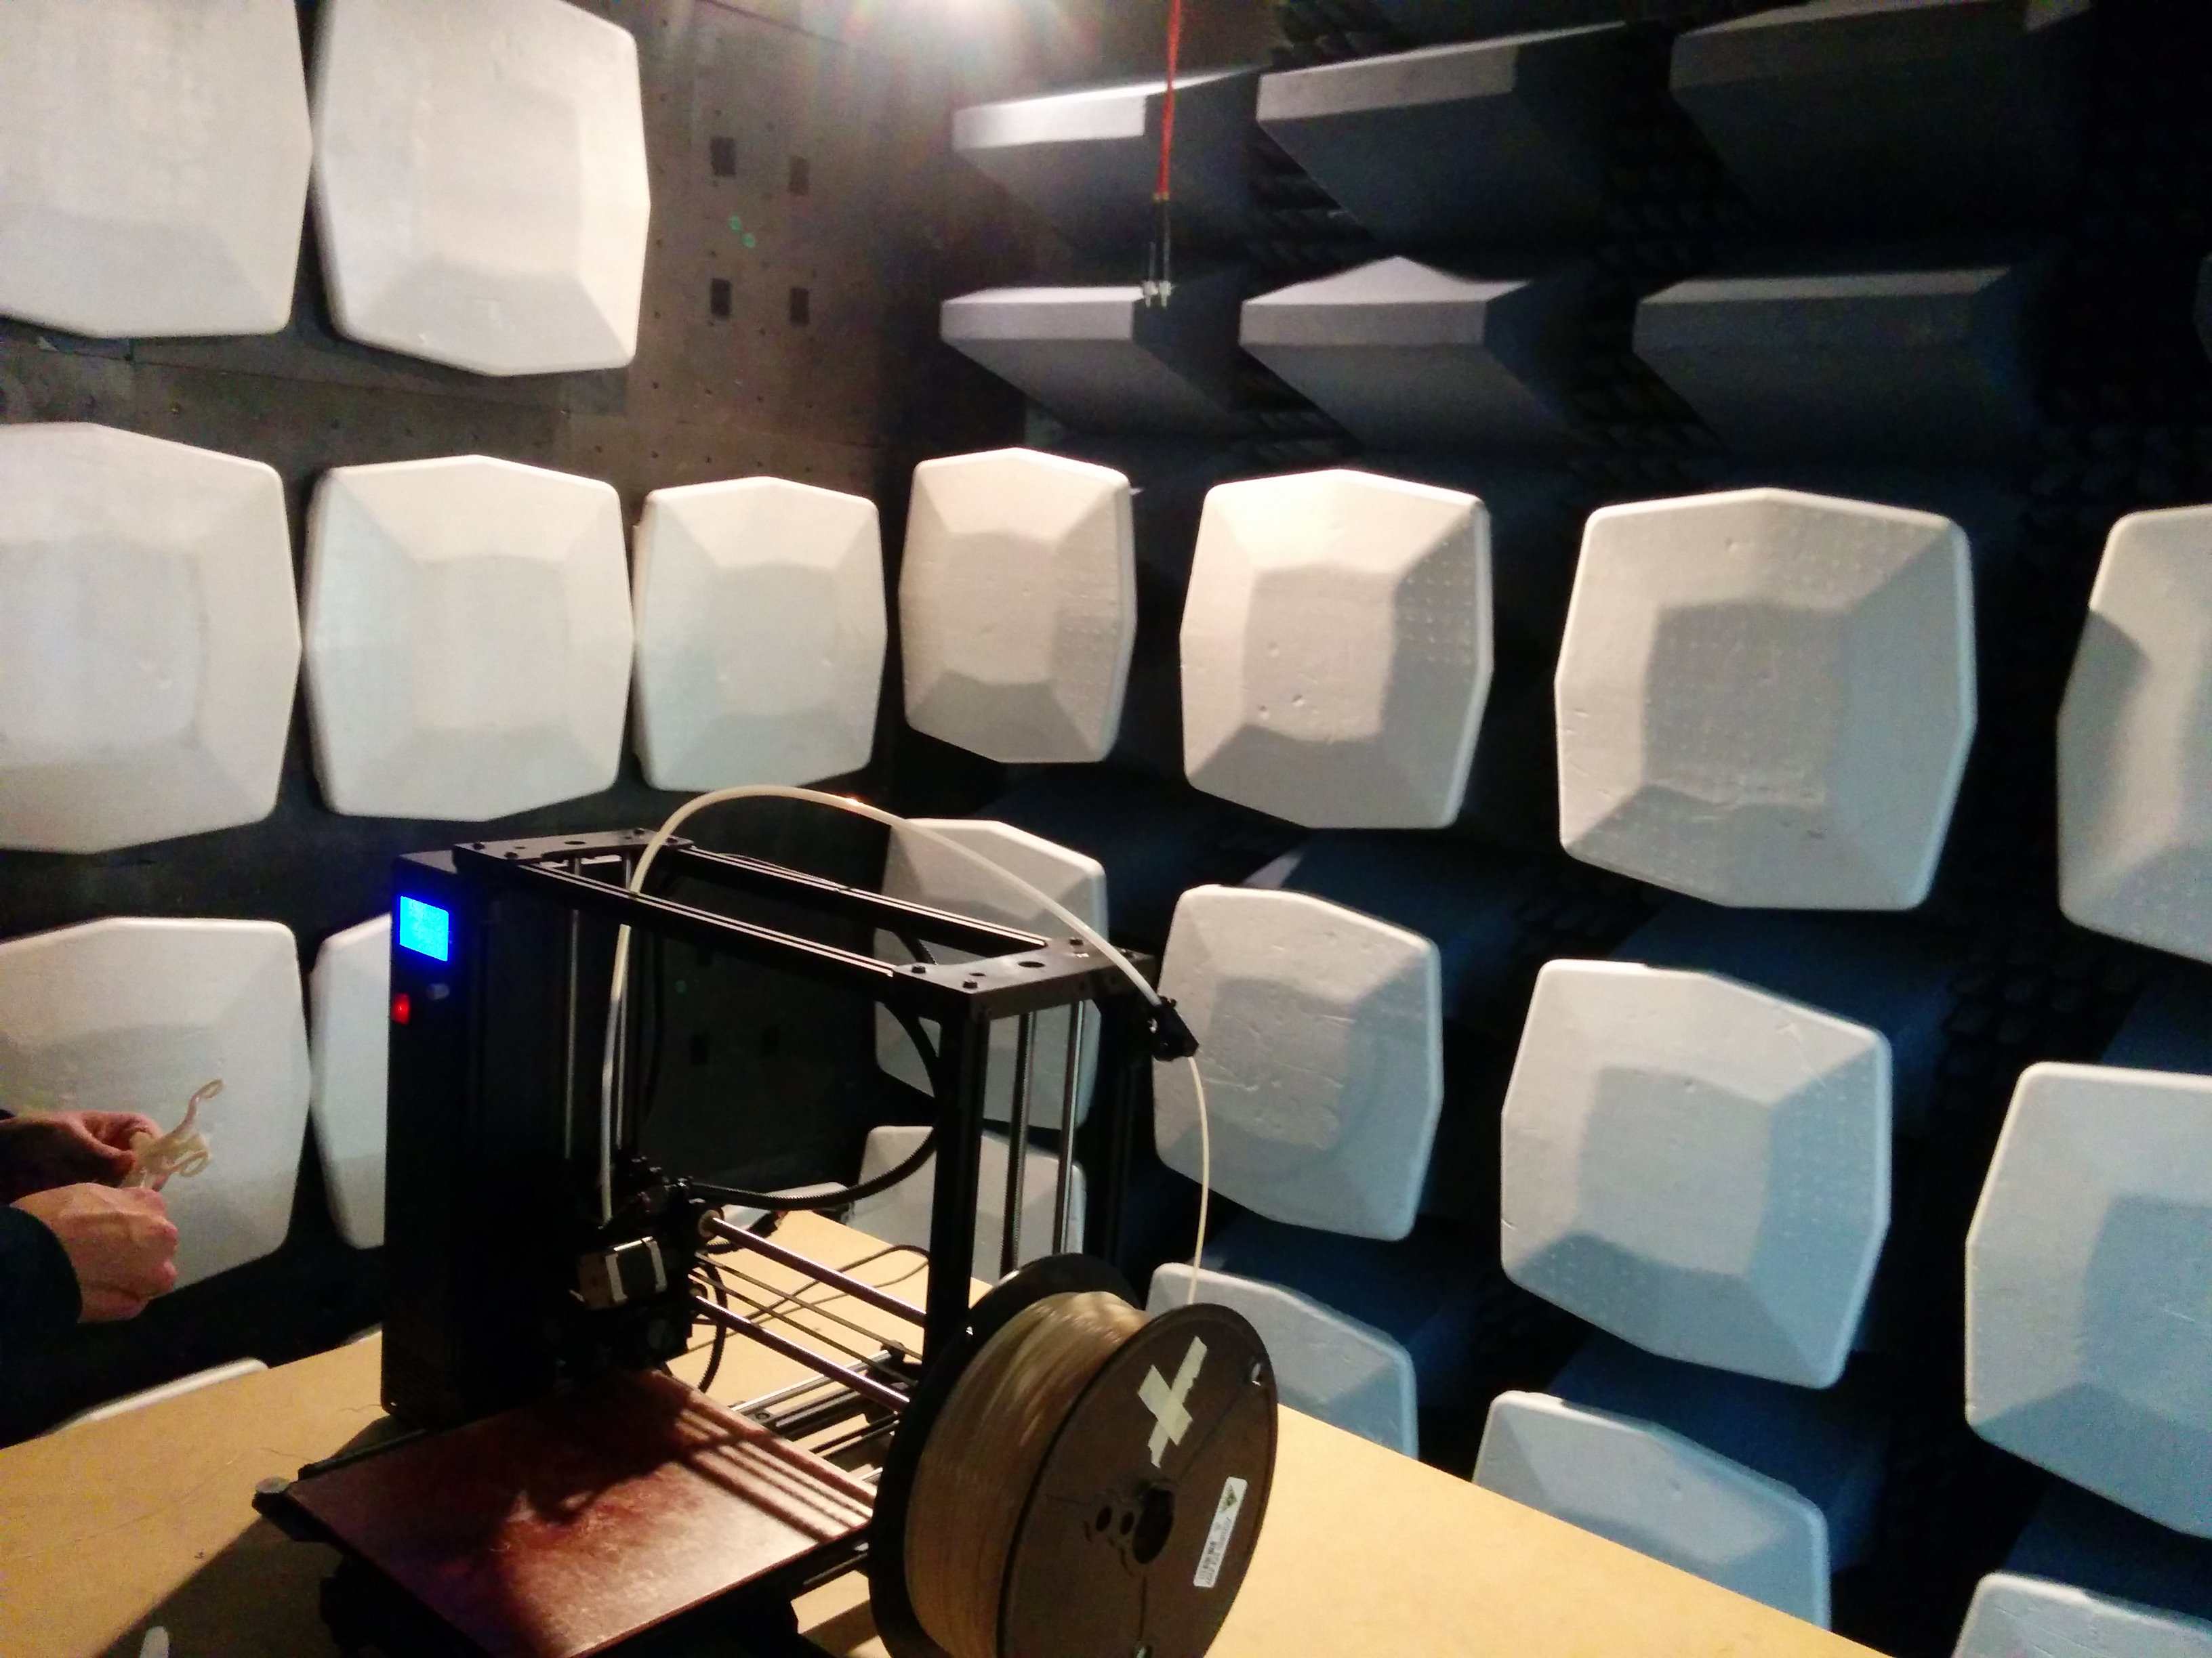

PROCEDURE:

EMI Testing Procedure:
Place the machine on the turning table in the EMI chamber. Run through the spectrum (30MHz – 1GHz) with the antenna in its horizontal and vertical positions. If any frequency is above the specified limit then examine those frequencies individually and move and/or unplug wires to find the source.

ESD Testing Procedure:
Place an earth grounded metal sheet on a table, place an insulating sheet on top of the metal sheet. Place the machine on the insulating sheet such that it does not touch the metal sheet. Probe various suspicious/potentially susceptible locations (e.g. LCD display metal frame, auto-bed leveling washers) with ±4kV discharges. Also probe seemingly insulated areas (e.g. LCD display) with the round tip at ±8kV. If either test fails then proper insulation and/or grounding needs to be introduced. Insulating materials that have a ±8kV breakdown voltage between its surface and the sensitive location is needed.
TEST DATA and COMPLETE RESULTS:

The following data was gathered on 11/20/2015 when Mangrove 03 passed the Class B requirements:
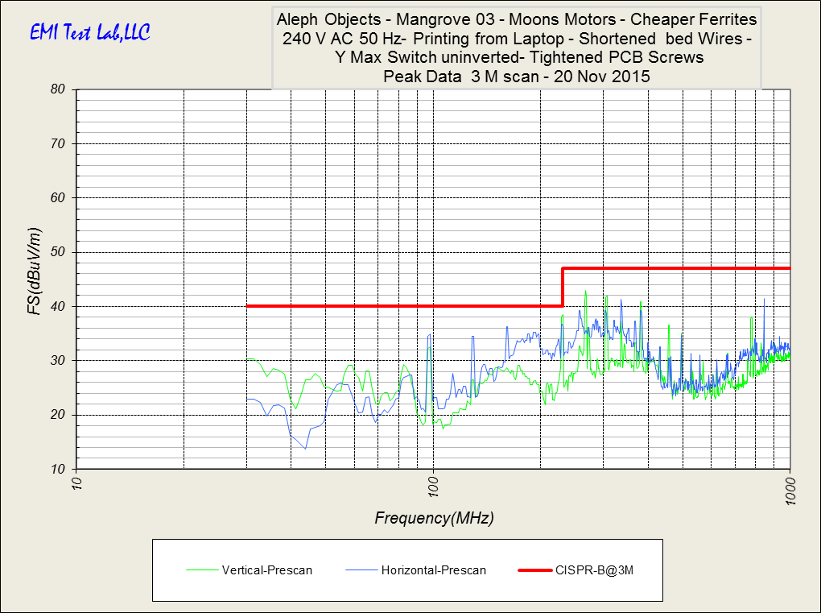

EMC Test Data:

Here is a table summarizing the frequencies closest to the limit:

Any value on the Limit delta column greater than 0dBμV/m would be considered failing Class B.

Conducted emissions test results prior to using the AC filter:

Conducted emissions test results after to using the AC filter (line):

Conducted emissions test results after to using the AC filter (neutral):

OTHER INFO:

Class B is required to market the machine as a consumer product as well as selling it to some large retail stores.

Dennis King from EMI Test Lab LLC mentioned that FCC regulation will probably change within the coming weeks such that products classified as unintentional radiators (computer peripherals or not) are not required to have an ISO accredited lab inspect the product.

