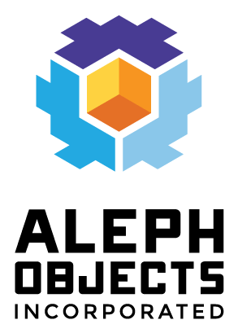

ETM Software Meeting
7/11/2014

- UI Design Ownership
- Slic3r
  - INI's
  - ARM version (Alessandro)
- IDE's
- LED Driver
- Fork/streamline linksprite kernel/image creation
- Web Daemon
- Lima Driver (Keith Packard)
- Package Slic3r, Octoprint, Custom code
- Protecting rootfs

