PP-MP0205_Procedure
Manufacturing Engineering
Mike Rosenhagen
10-2-18

This is the procedure to find the critical dimensions for PP-MP0205, E3D Aero steel pinion gear. The critical dimensions we are looking for are the height of the gear, the diameter of the gear, the diameter of the inner hole that slides onto the motor, and we are looking for the height of the set screw hole. To find these dimensions you will need a pair of calipers and a set of pin gauges.
The first dimension we will look for is the height of the gear. To do this, take a pair of calipers making sure to zero it out before taking each measurement. Take the gear in one hand and the calipers in the other. Use the thumb wheel to close the jaws on the gear until the jaws will not close anymore.
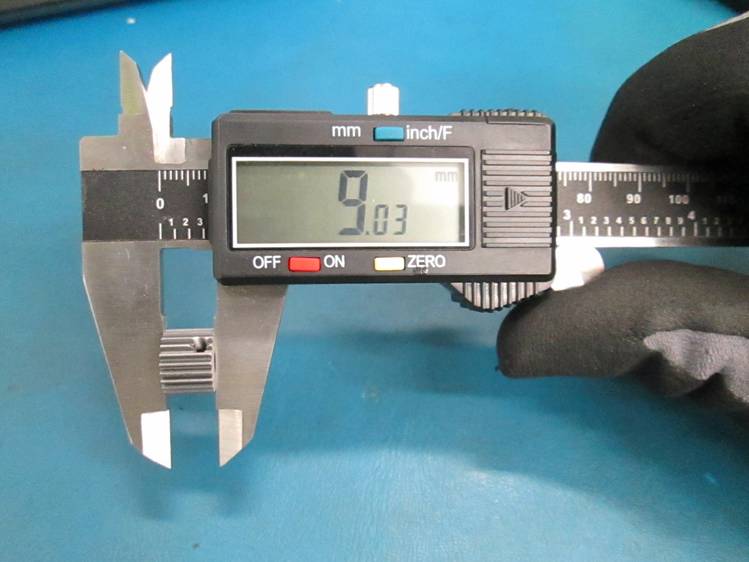

Next we will find the diameter of the gear as a whole. Similar to finding the height, take the gear in one hand and the calipers in the other. Using the thumb wheel close the jaws of the calipers around the gear till the calipers will not close anymore.
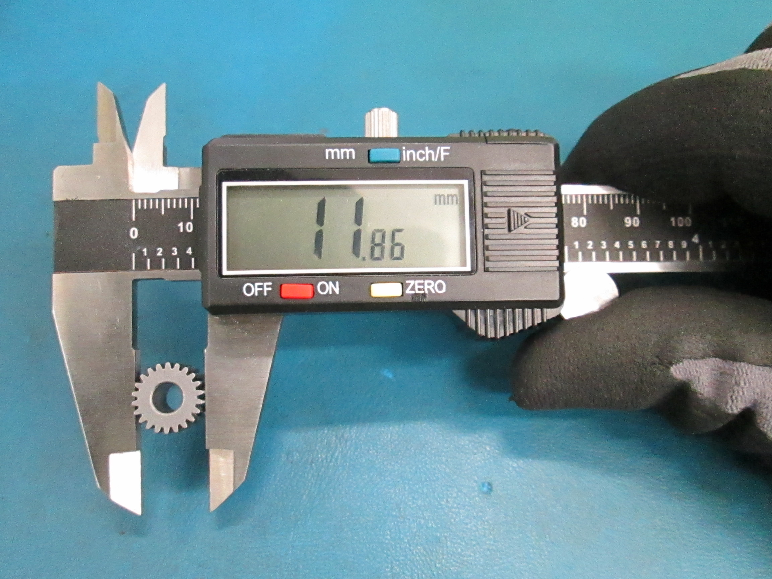

Now we will find the diameter of the inner hole that slides over the motor shaft. To do this you will need a set of pin gauges ranging from 4.9mm to 5.06mm. I would recommend starting with a 5mm pin gauge. If the pin gauge does not slide into the hole go down one size until you find one that will slide into the hole snugly. The pin gauge should not be forced into the hole or be able to wiggle inside the hole. If the pin gauge has wiggle room increase the size of the pin gauge by one until you find one that slides in snugly.
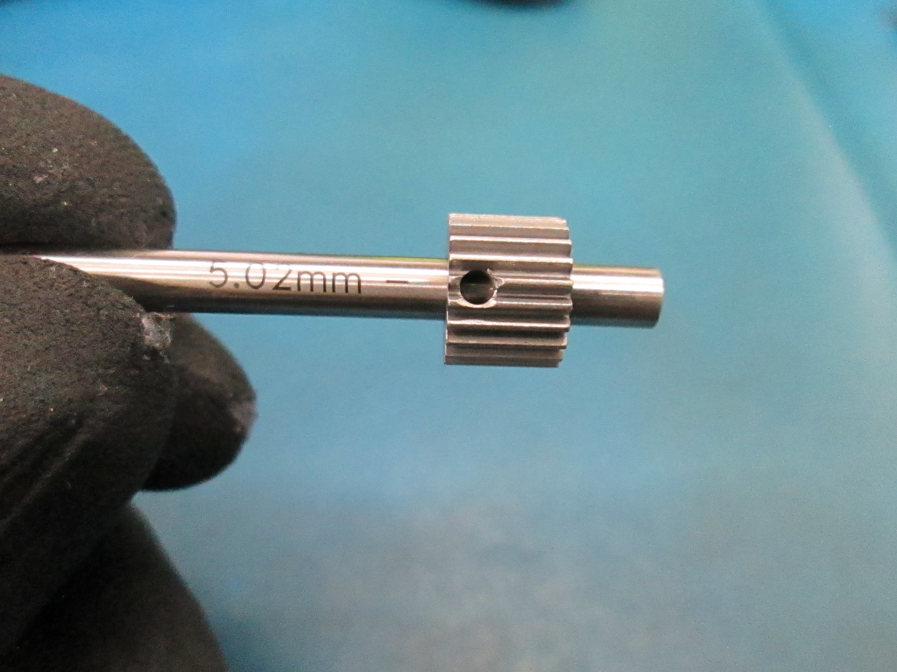

The last dimension we will find is the height of the set screw hole. To do this you will need a some pin gauges and a set of calipers. First find a pin gauge that fits into the set screw hole snugly without being forced into the whole and has no wiggle room. IF the pin gauge can wiggle you will get an inaccurate measurement. Once you have a good pin in the hole, take the calipers and using the depth gauge part of the calipers, measure the distance from the bottom of the gear to the bottom of the pin gauge.


