HD-EX0090_Procedure
Manufacturing Engineering
Mike Rosenhagen
10-3-18

This is the procedure to find the critical dimensions for HD-EX0090, Aluminum Extrusion Corner Brace Support. The only critical dimension we will look for is the angle of the corner bracket which should be 90 degrees. To find the angle of the corner brace you will need a machinist square, two extrusion bars roughly 305mm long, a couple t-nuts with screws and washers, and a set of pin gauges. There will also be a little math involved.
Start by placing one t-nut into each extrusion bar near the edge of the bar.
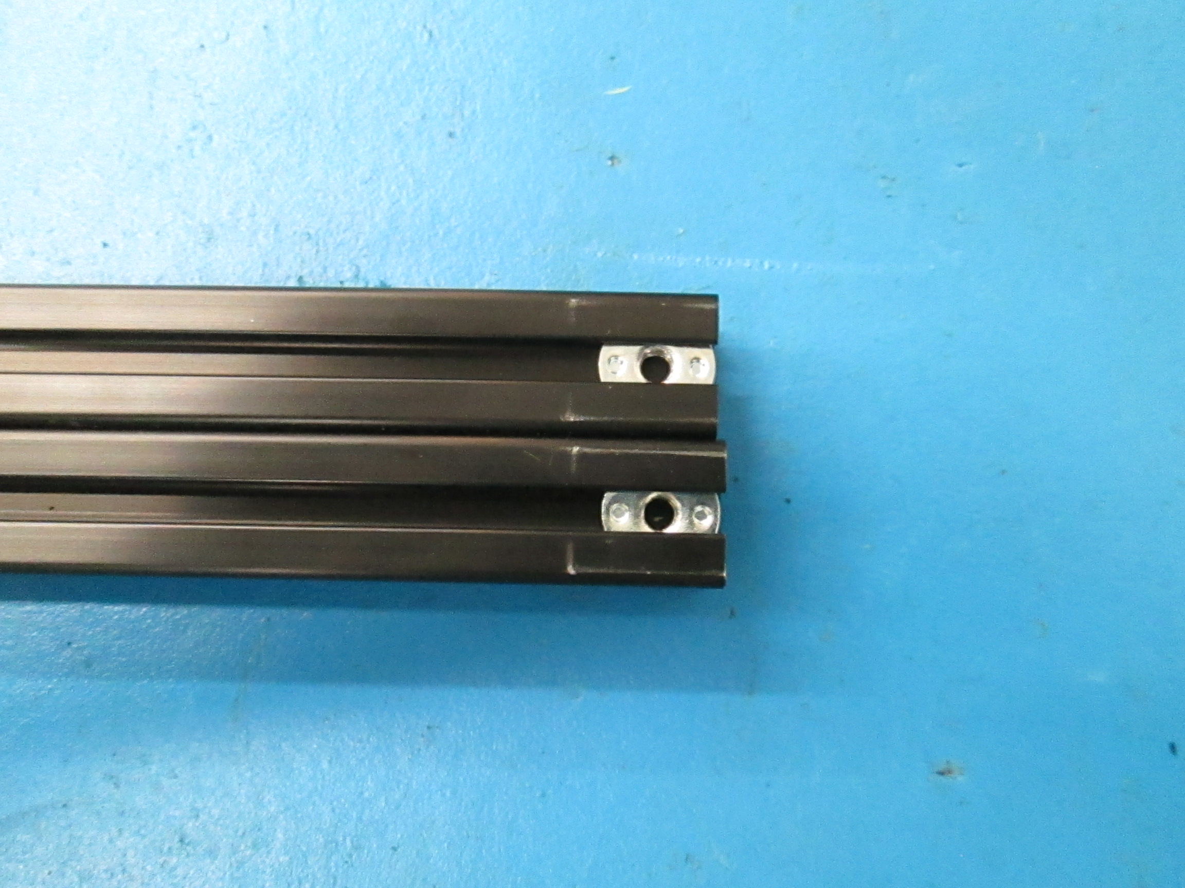

Now take the corner brace and attach it to each extrusion bar making sure each bar is flush with the edge of the corner brace.
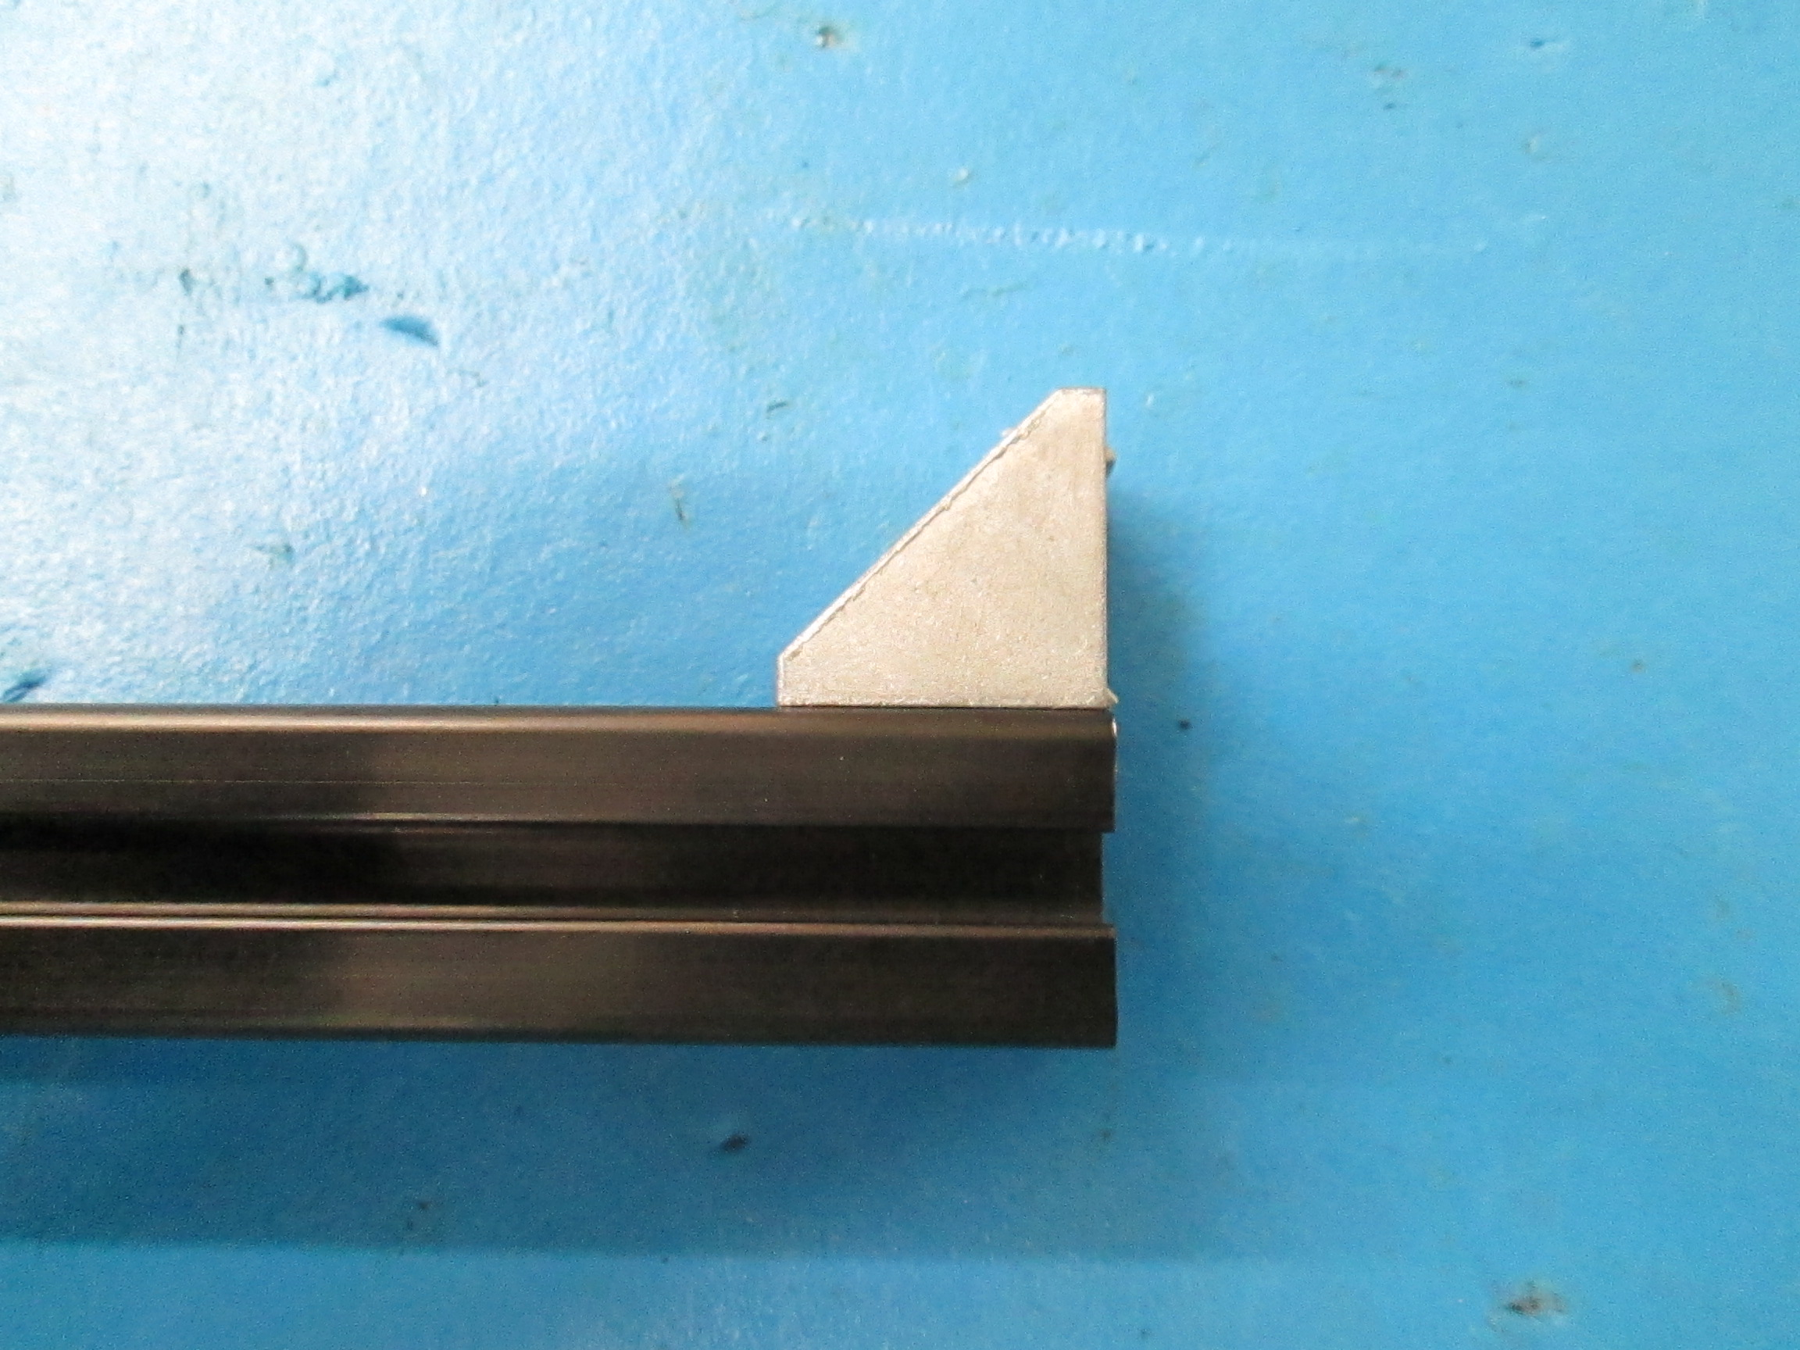
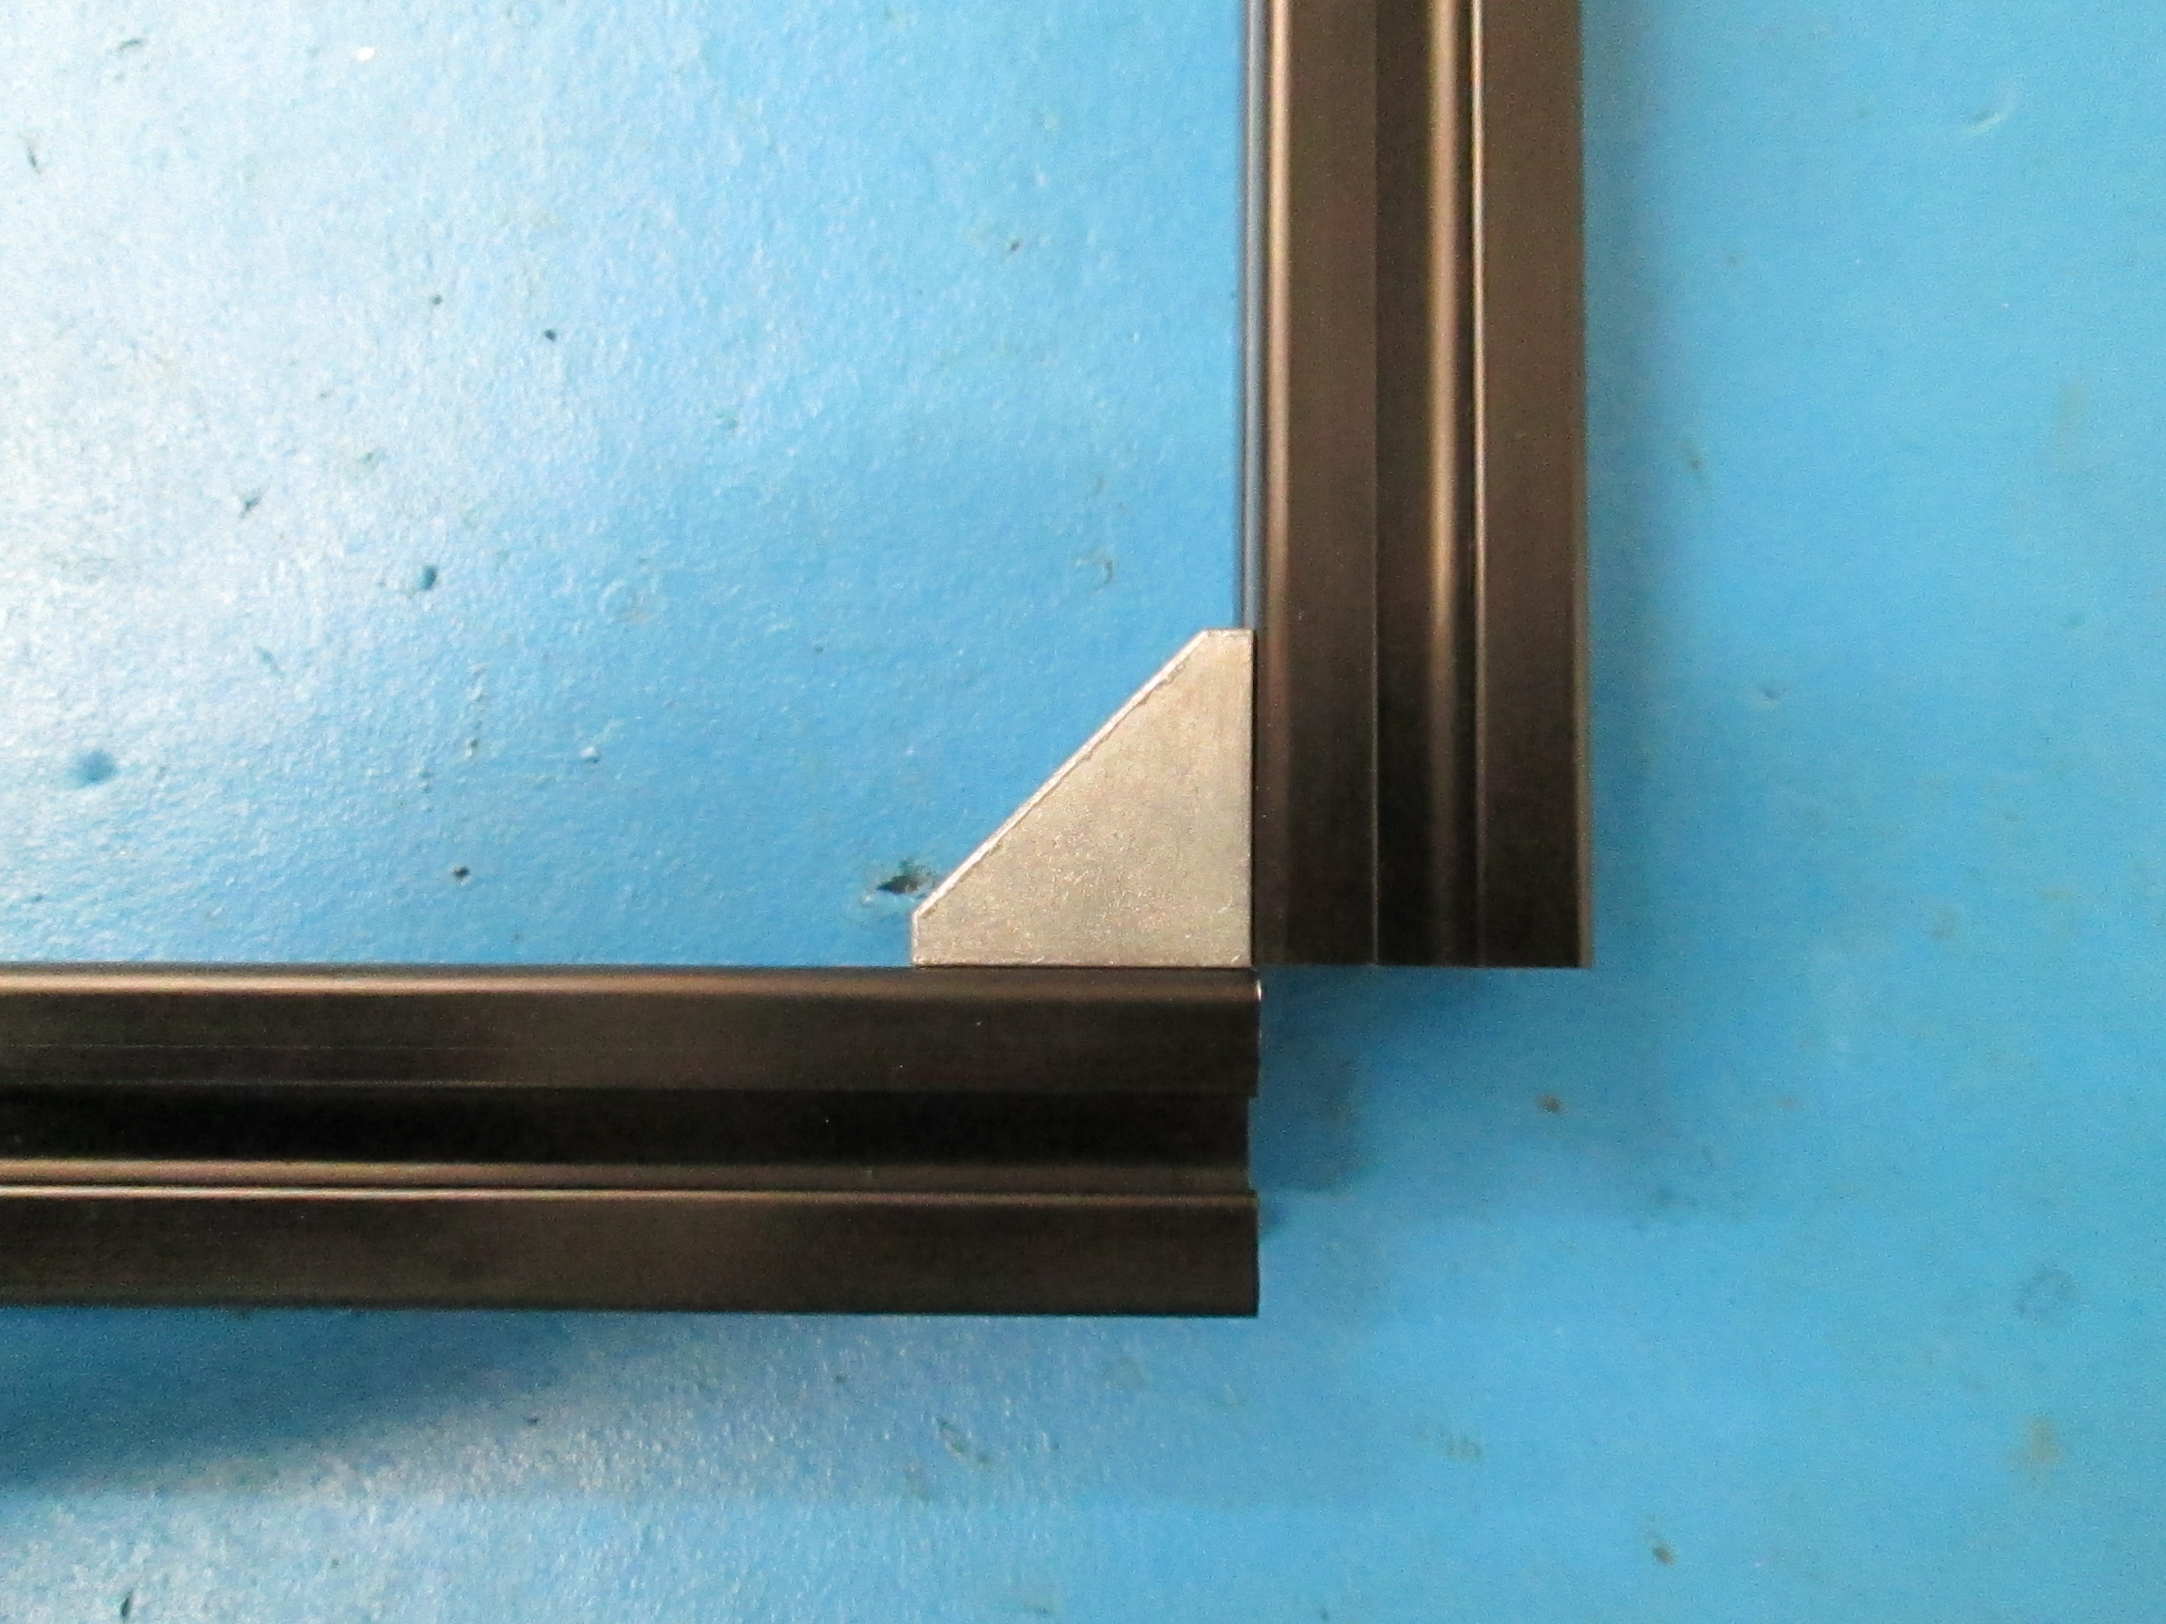

The bars should make an L shape. Slide the brace and bars to the machinist square. If the corner brace is exactly flush with the square then that means the brace is at the ideal 90 degrees. If the brace is not exactly at 90 you will notice a gap at either the top or the bottom of the square.
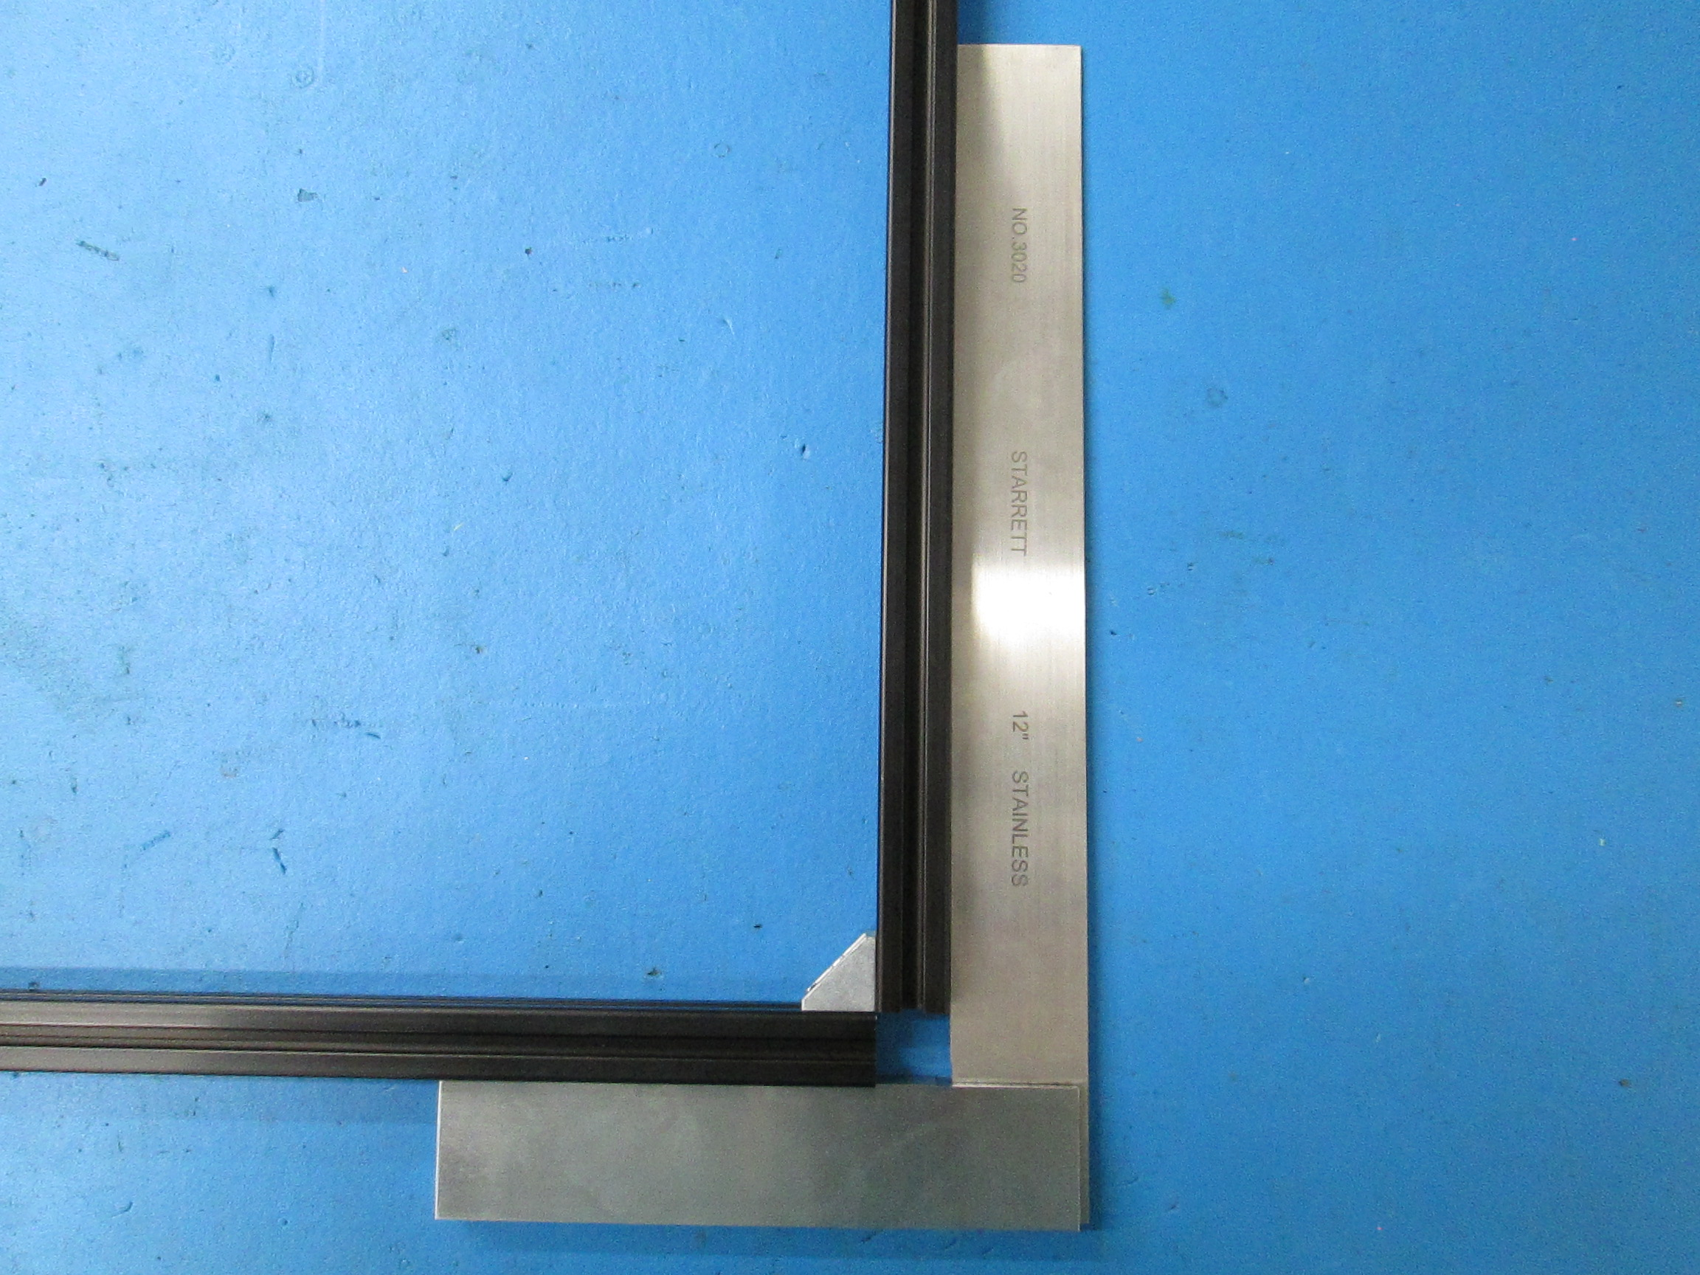
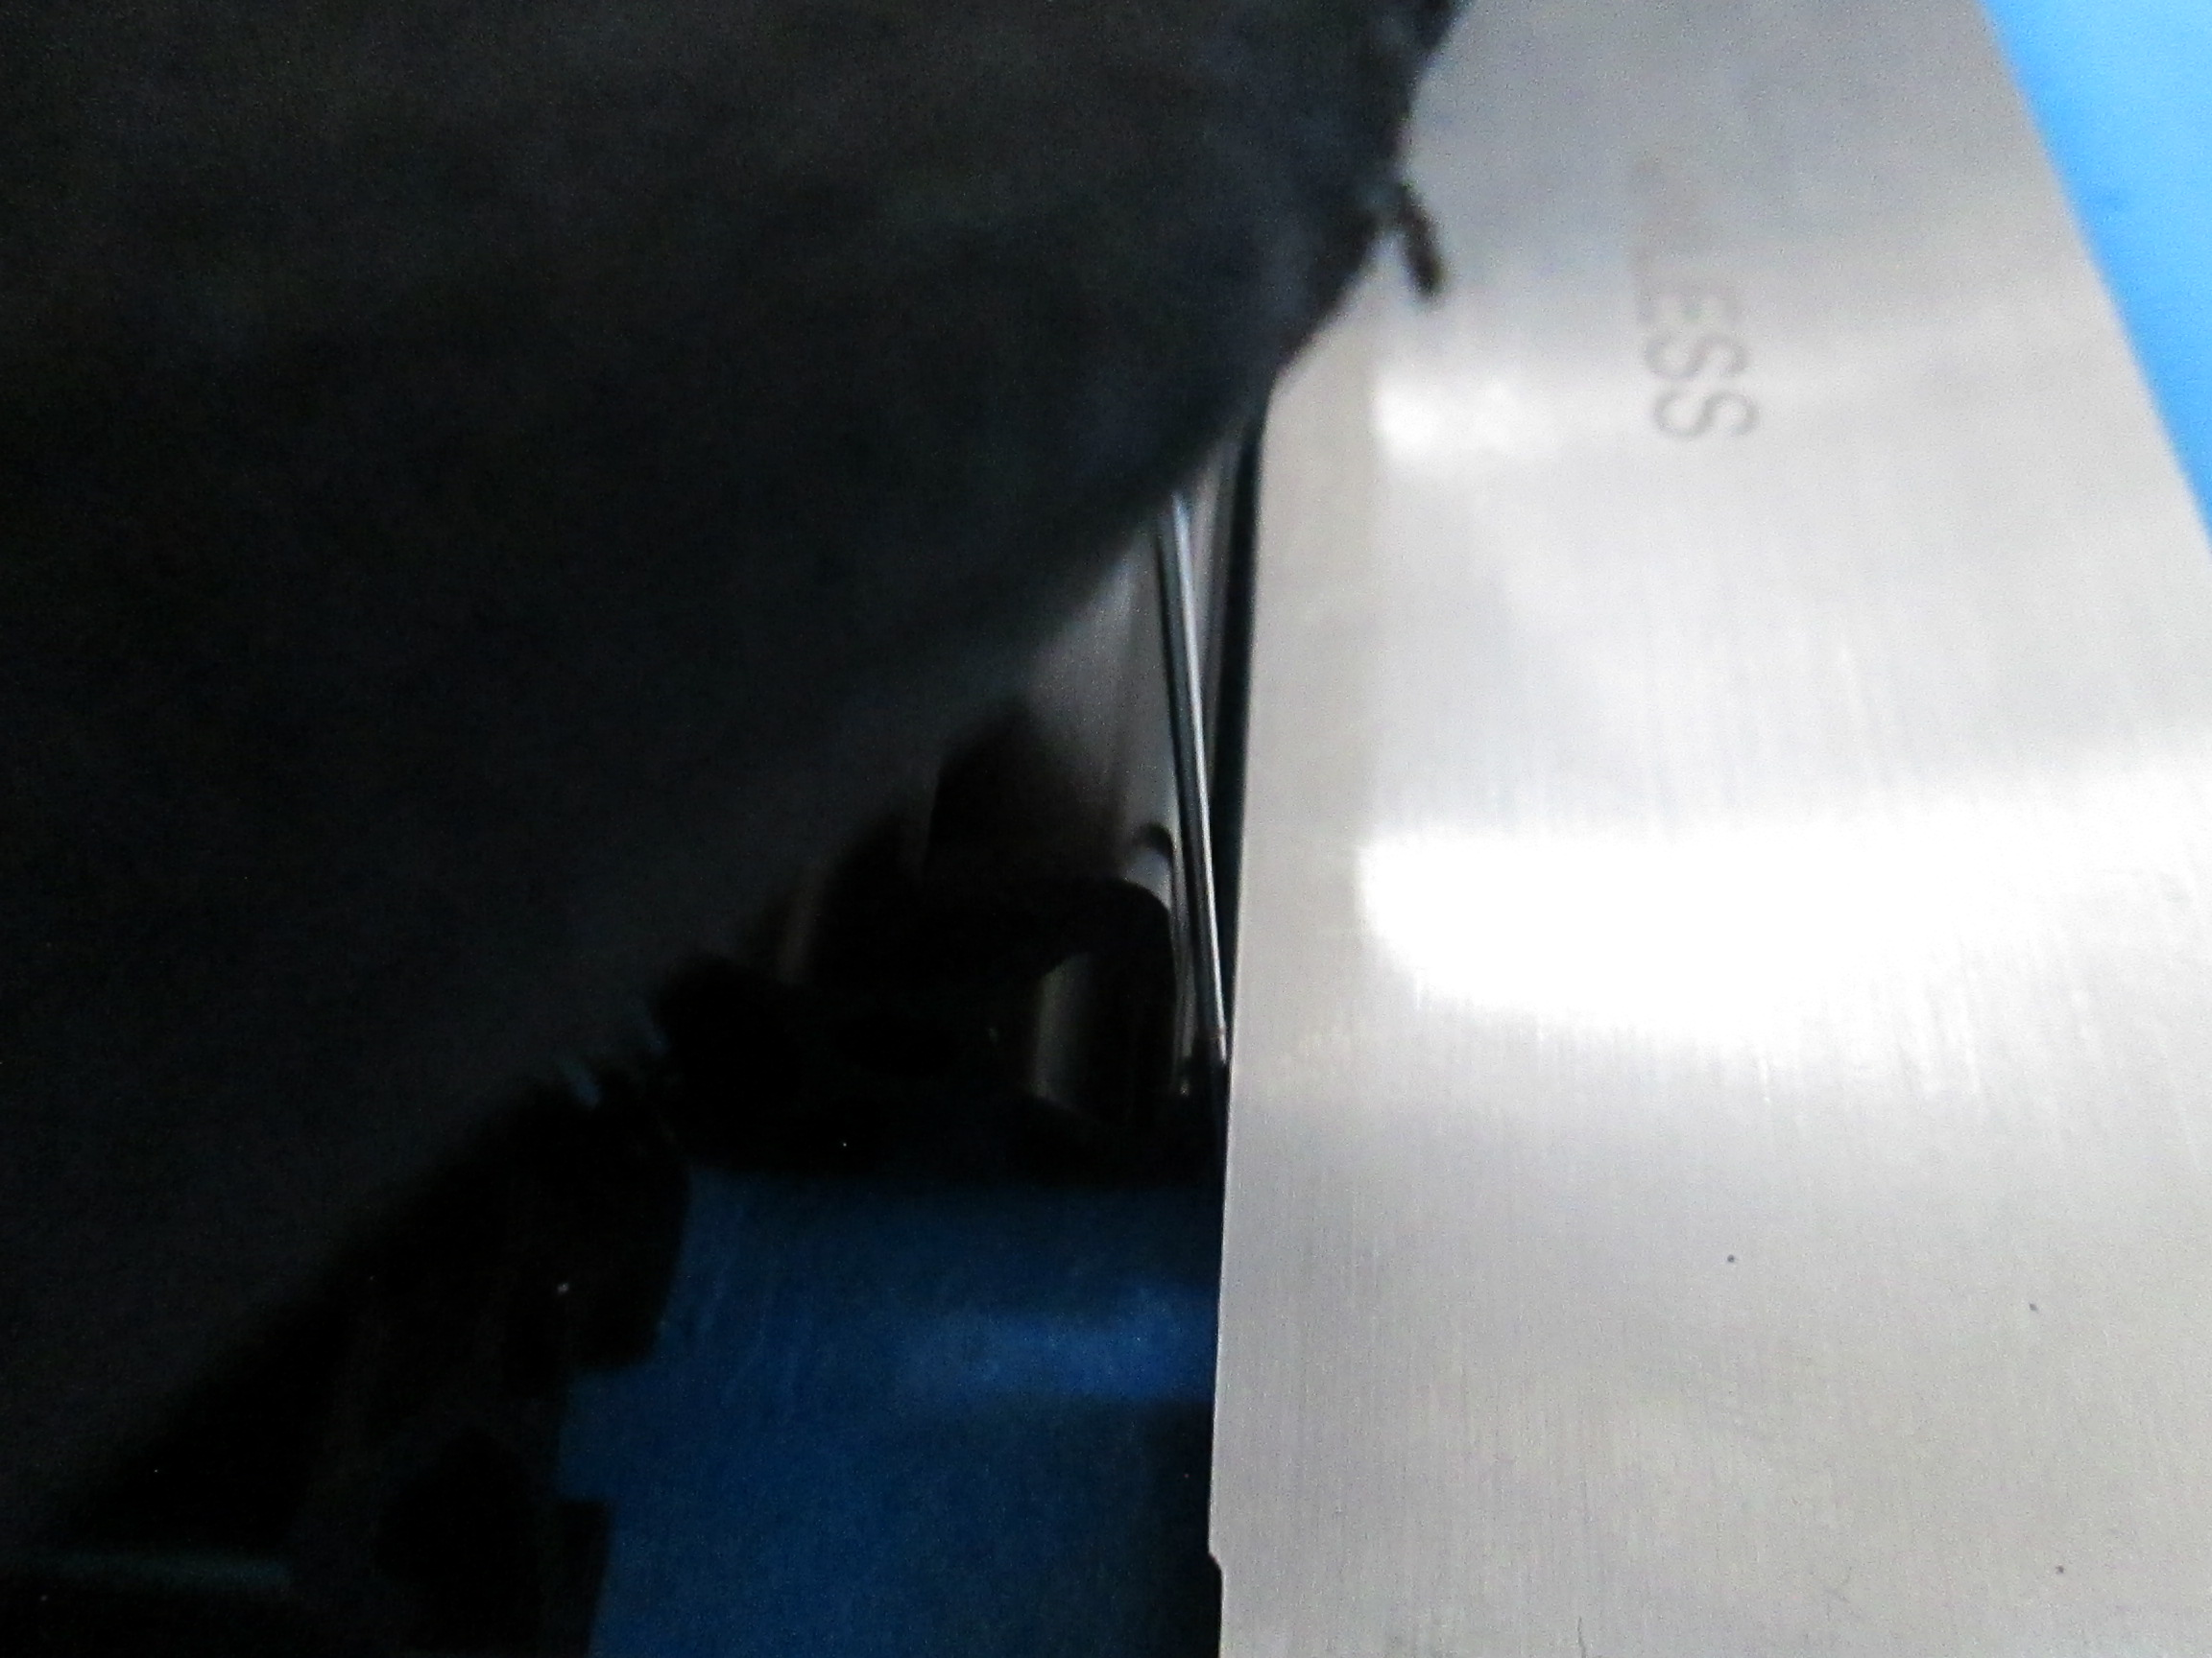

If the gap is at the bottom this means the corner brace is at an obtuse angle or it is greater than 90 degrees. If the gap is at the top of the square this means the corner brace is at an acute angle or it is less than 90 degrees.
If you find that there is indeed a gap between the extrusions and the square you will need to use a pin gauge and find out how big the gap is. You will need this number to calculate the actual angle of the corner brace. If the gap is at the bottom of the square, think of this as a positive number. If the gap is at the top of the square, think of this as a negative number. Here is where the math gets involved.
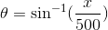
X is the size of the gap we find. Once you get your number, plug in your number for x and do the equation then add 90 to get the actual angle of the corner brace.

