AO-Hex Hotend-Subassembly – Juniper and Fangtooth

Required Tools: Torque wrench with 7mm crows foot adaptor, 18mm open end wrench, 4.5mm open end wrench, 1.5mm hex screwdriver, 2mm hex screwdriver, high temperature thread-locking compound

- Unscrew heatsink and nozzle – reinstall nozzle using a 7mm torque wrench and holding the heater block with a 18mm wrench. Tighten to 30 in*lbs. Make sure that the nozzle says 5 on the side (0.50mm nozzle).

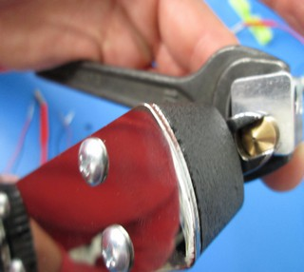
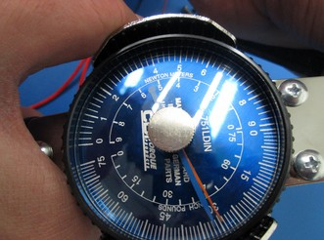

- Apply thin coat of high temperature threadlock to the entire threaded portion and re-install in the heater block. Install tightly using a 4.5mm wrench and holding the heater block with a 18mm wrench
  - If possible, rotate the heatsink so that one of the points of the heatsink faces the front and the set screw hole is somewhere in the back.
- Lock the threaded extension into the heatsink using an M2x6 SCHS with a small amount of high temperature thread lock.
- Cut thermistor wires to 200mm and crimp on male pins
- Cut the heater cartridge wires to 205mm and crimp on male pins
- Take thermistor and pull back both pieces of the black shielding 1/2”
  - Make sure that the inner clear plastic tubing is all the way down to the bead of the thermistor
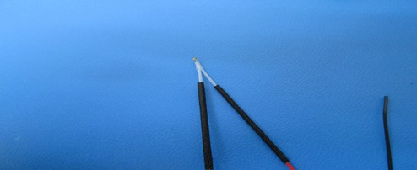
- Slide ONE of the pieces of black shielding down to the bead of the thermistor and insert into the heater block
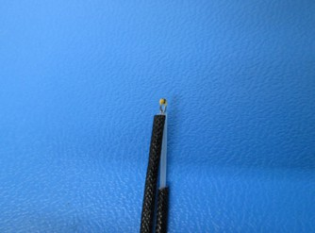
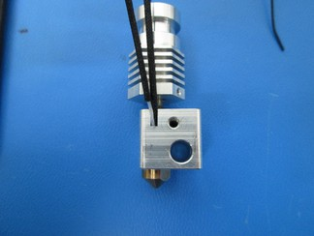
- Holding the thermistor leads in place, install the heater cartridge, but do not lock in place yet
- Secure heater cartridge and thermistor into the side of the heat block with a retention plate and an M3x6 BHCS.
  - Be sure that the retention plate is tightened seated completely flush against the block
  - Make sure that the front edge of the plate is parallel to the front face of the heater block.
  - Make sure that the retention plate is covering part of the heater cartridge
  - Make sure that both leads of the thermistor are in the channel in the side of the heater block and not pinched against the flat face. One of the 2 black shield bits should be secured by the retention plate, the other should rest flush with the top of it.
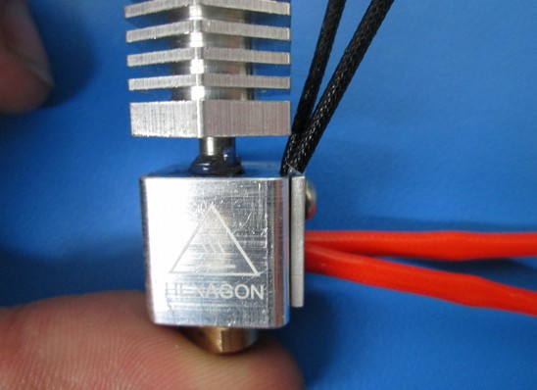

- Pull heater cartridge up against the retention plate and lock into place with am M3x6 set screw from the rear of the heater cartridge.
- Install the heater cartridge wires in pins 1 and 2 of a 4pin connector, and the thermistor wires in pins 3 and 4.

Printhead build
- Build up a hexagon version of the standard TAZ extruder (it will have a hole in the bottom for the top of the hexagon nozzle)
  - Use only black sealed bearings for the extruder
- Mount the hexagon hotend and the extruder on the hexagon extruder mount (It's slightly longer than the one used on the TAZ 4, with a circular cutout for the large gear).
  - Make sure to line up the filament path with an over-sized bit of filament before tightening down.
- Attach a micro blower to the front of the mount with an M2x6 SCHS
  - the micro-blower should have 160mm leads with male pins in a 2-pin housing. The red lead should go in pin 1 and the housing should be marked with blue paint.
- Attach the extrusion fan with shroud to the side of the extruder mount, it's the same exact one we used on the TAZ 4.
- Make sure that all of the wires except for the stepper motor wires are running up between the extruder body and the motor.
- Zip tie all wires into a bundle 1 inch below the connector housings.

Differences from TAZ 4 printhead

- uses hexagon style extruder body (has circular hole in bottom for top of hexagon hotend).
- uses hexagon style extruder mount (has circular cutout for large gear)
- uses black sealed bearings all around
- mini blower with 160mm leads and it's own 2pin connector marked with blue paint

Differences from the Mini printhead
- wire lengths for micro blower, thermistor and heater cartridge all changed
- uses a 0.35mm nozzle for the hexagon hotend
- There isn't a grounding lug on this hotend
- Uses TAZ extruder mount, but same extruder body
- Uses black sealed bearings
- Uses standard 24V TAZ extrusion fan

